Religious Studies: Philosophy and Ethics

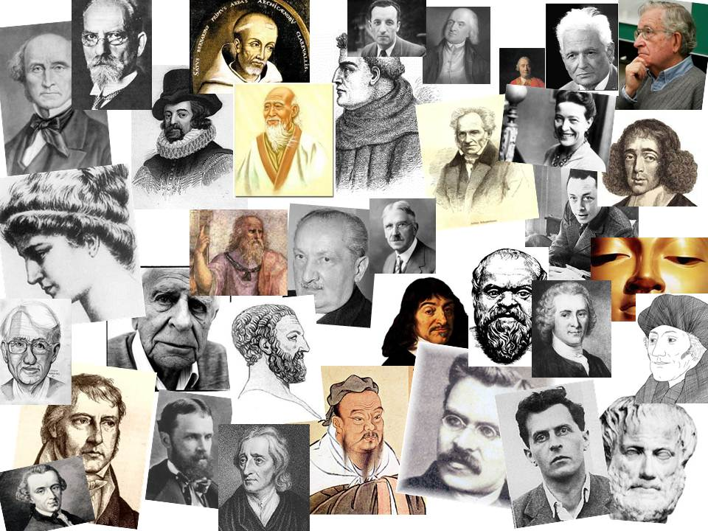

Teacher:

Mr P Edwards (Head of REP)
pedwards@bristolcathedral.org.uk

RS: Philosophy and Ethics

Welcome to the RS: Philosophy and Ethics course at BCCS. Hopefully you are looking forward to expanding your knowledge and skills in some of the most fascinating areas of human thought. The next two years will be exciting, hard, fun, frustrating, intriguing, brilliant, and many more things that you have yet to experience. You will have the chance to explore the thinking of philosophers throughout history, from Plato to Peter Singer, from Aristotle to Richard Dawkins, as well as your own ideas, and those of your colleagues. The skills you learn during your time here will help you to develop critical thinking, leadership, discussion and essay technique, empathy and confidence. Enlightenment awaits…

Expectations

From the start of year 12 you will be expected to show more independence and organisation than at GCSE level. You will need to be pro-active in background reading on the topics we study, in order to give yourself the best possible chance of achieving a high grade. While your teacher will be able to point you in the right direction, your self-motivation is very important.

You will need to keep all work, essays and feedback in a well-organised file that should be brought with you to every lesson. This will be incredibly helpful when it comes to revision and will also mean that you are able to refer back to previous work throughout the course.

You are expected to attend every lesson and to arrive on time. If you are unable to do so for any reason, you will need to take responsibility for catching up on what you have missed. The nature of the course means that you cannot afford to miss work.

Possibly most important of all, you are expected to listen. Your fellow students and your teacher are there to help and support you, but that will only happen if you are prepared to take on board what is said by others. A good grade at A level depends on your understanding of multiple points of view.

What you can expect from us

You will have four lessons a week from a qualified and passionate RS: Philosophy and Ethics specialist, who will work hard to make sure your lessons are engaging and will certainly cover everything you need to succeed in your OCR Philosophy and Ethics exam.

You will receive feedback on your work, in order to ensure you know how to improve and progress. This feedback is vital if you are to achieve your potential, so make sure you value it and use it to inform your next piece of work.

You will have the resources, including various text books, original texts and IT, to help you gain the knowledge that you need to succeed. You will also be surrounded by fellow philosophers, who are often the greatest resource of all!

Career possibilities

The course has implications for every possible career path. The ability to think through issues within the workplace arises in every field from medicine to law, high finance to social work. The ability to present your ideas well lies at the heart of any successful career, and will make you a leader rather than a follower. Confident self-expression with an understanding of a wide range of viewpoints is good preparation for a variety of careers which require teamwork and individual initiative.
RS: Philosophy and Ethics (Year 12)

Course Content:

- Philosophy of Religion

God and the world
- Religious Experience
- The Problem of Evil

Philosophical Language and Thought
- Ancient philosophical influences
- Soul, Mind and Body

The Existence of God
- Arguments based on observation
- Arguments based on reason

- Religion and Ethics

Applied Ethics
- Business Ethics
- Euthanasia

Deontological and Teleological Theories
- Kantian Ethics
- Utilitarianism

Religious Ethics
- Natural Law
- Situation Ethics

- Developments in Religious Thought

Foundations
- Knowledge of God’s existence
- The person of Jesus Christ

Insight
- Augustine on human nature
- Death and the afterlife

Living
- Christian moral action
- Christian moral principles

RS: Philosophy and Ethics (Year 13)

Course Content: All of Year 12 PLUS:

- Philosophy of Religion

Religious Language – 20th Century Thought

Religious Language – Negative, Analogical or Symbolic

Theological and Philosophical Developments
- The nature and attributes of God

- Religion and Ethics

Meta-Ethics
- Meta-ethical theories

Developments in ethical thought
- Sexual Ethics

Significant Ideas
- Conscience

- Developments in Religious Thought

Challenges
- Liberation Theology and Marx
- The Challenge of Secularism

Development
- Religious pluralism and society
- Religious pluralism and theology

Society
- Gender and society
- Gender and theology

Assessment: Students study 3 x 2 hour written papers at the end of the two year course. There is no coursework.

Specification: OCR H573

Year 12 Preparatory Work

Philosophy and Religion

- ‘There is no evidence for the existence of God’ Discuss. You should produce a piece of work at least 6 paragraphs in long. It must show understanding of at least three different points of view, including a religious view. Your own conclusion should be fully supported.
- Keep up to date with the news on the BBC web-site and make a note of anything you think might be relevant to the content of the course.

Ethics and Religion

- ‘Killing another human being is always wrong’ Discuss. You should produce a piece of work at least 6 paragraphs long. It must show understanding of at least three different points of view, including a religious view. Your own conclusion should be fully supported.
- Keep up to date with the news on the BBC web-site and make a note of anything you think might be relevant to the content of the course.

Also: Read ‘Sophie’s World’ by Jostein Gaarder: https://www.amazon.co.uk/Sophies-World-Novel-History-Philosophy/dp/1857992911

There is a reading list that is also useful for any background reading you wish to complete and the full course specification is available here:

http://www.ocr.org.uk/qualifications/as-a-level-gce-religious-studies-h173-h573-from-2016/

You MUST come prepared with a file folder and some section dividers, as well as the usual expected equipment.

